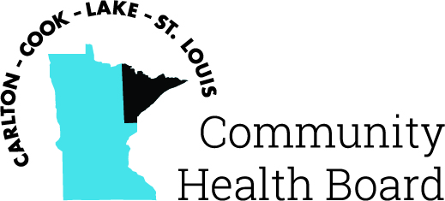

404 West Superior Street, Suite 250
Duluth, MN 55802
Phone: 218-733-2860
www.communityhealthboard.org

Notice of a Public Meeting

November 24, 2025

Notice is hereby given that a meeting of the Board of Directors
of the Carlton-Cook-Lake-St. Louis Community Health Board will be
held on Monday, December 1 at 12:30 p.m. at At Sarah’s Table Chester
Creek Café, 1902 E 8th Street, Duluth, MN for the purpose of conducting
regular business.

All voting members will be in attendance. For additional details
please contact
CHBSupport@CommunityHealthBoard.org

