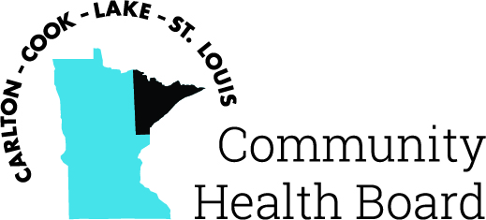

404 West Superior Street, Suite 250
Duluth, MN 55802
Phone: 218-733-2860
www.communityhealthboard.org

Notice of a Public Meeting

October 14, 2025

Notice is hereby given that a meeting of the Board of Directors
of the Carlton-Cook-Lake-St. Louis Community Health Board will be
held on Monday, October 20 at 12:30 p.m. at the Richard H. Hansen
Public Works and Transportation Complex located at 4787 Midway
Road, Pike Lake, MN for the purpose of conducting regular business.

Voting members will be attending in person and virtually. For
additional details please contact
CHBSupport@CommunityHealthBoard.org

