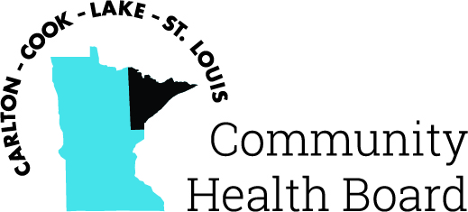

404 West Superior Street, Suite 250
Duluth, MN 55802
Phone: 218-733-2860
www.communityhealthboard.org

Notice of a Public Meeting

February 4, 2025

Notice is hereby given that a meeting of the Board of Directors
of the Carlton-Cook-Lake-St. Louis Community Health Board will be
held on Monday, February 10 at 12:30 p.m. at the Richard H. Hansen
Public Works and Transportation Complex located at 4787 Midway
Road, Pike Lake, MN for the purpose of conducting regular business.

All voting members will be present with the exception of
Commissioner Ashley Grimes who will be attending virtually from:
427 N 43rd Ave W, Duluth, MN. For additional details please contact CHBSupport@CommunityHealthBoard.org.

