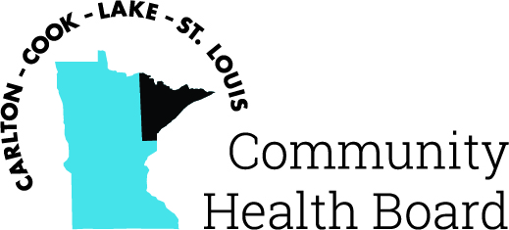

404 West Superior Street, Suite 250
Duluth, MN 55802
Phone: 218-733-2860
www.communityhealthboard.org

Notice of a Public Meeting

November 26, 2024

Notice is hereby given that a meeting of the Board of Directors of the Carlton-Cook-Lake-St. Louis Community Health Board will be held on Monday, December 2 at At Sarah’s Table Sky Room Meeting Room, 1902 E. 8th Street, Duluth, MN for the purpose of conducting regular business.

All voting members will be present. For additional details please contact CHBSupport@CommunityHealthBoard.org.

