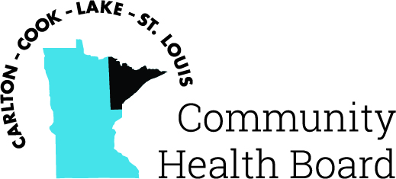

404 West Superior Street, Suite 250
Duluth, MN 55802
Phone: 218-733-2860
www.communityhealthboard.org

Notice of a Public Meeting

October 17, 2024

Notice is hereby given that a meeting of the Board of Directors
of the Carlton-Cook-Lake-St. Louis Community Health Board will be
held on Monday, October 21at 12:30 p.m. at the Richard H. Hansen
Public Works and Transportation Complex located at 4787 Midway
Road, Pike Lake, MN for the purpose of conducting regular business.

All voting members will be present with the exception of
Patrick Boyle. For additional details please contact CHBSupport@CommunityHealthBoard.org.

