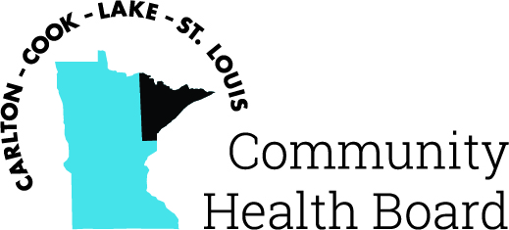

404 West Superior Street, Suite 250
Duluth, MN 55802
Phone: 218-733-2860
www.communityhealthboard.org

Notice of a Public Meeting

August 8, 2024

Notice is hereby given that a meeting of the Board of Directors
of the Carlton-Cook-Lake-St. Louis Community Health Board will be
held on Monday, August 12, 2024, at 12:30 p.m. at the Richard H. Hansen
Public Works and Transportation Complex located at 4787 Midway
Road, Pike Lake, MN for the purpose of conducting regular business.

All voting members will be present except for Commissioner
Rick Hogenson who will not attend and Commissioner Rick Sve will
attend as an alternate in his place.
The following Board members will be attending virtually:
Commissioner Patrick Boyle - 2201 E 1st St Duluth, MN
Commissioner David Mills - 411 W 2nd Street, Grand Marais, MN

For additional details please contact CHBSupport@CommunityHealthBoard.org.

