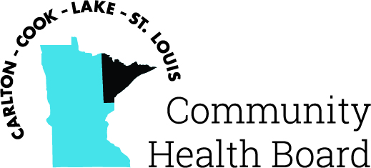

404 West Superior Street, Suite 250
Duluth, MN 55802
Phone: 218-733-2860
www.communityhealthboard.org

Notice of a Public Meeting

June 5, 2024

Notice is hereby given that a meeting of the Board of Directors
of the Carlton-Cook-Lake-St. Louis Community Health Board will be
held on Monday, June 5, 2024, at 12:30 p.m. at the Richard H. Hansen
Public Works and Transportation Complex located at 4787 Midway
Road, Pike Lake, MN for the purpose of conducting regular business.

All voting members will be present except for the following who
will be attending virtually:
Frank Ceo – 302 Mile Old Pine, Grand Marais, MN
Commissioner Ashley Grimm
Commissioner Rick Hogenson - 613 3rd Avenue, Two Harbors, MN
Commissioner David Mills - 25202 121st St. Trevor, WI

For additional details please contact CHBSupport@CommunityHealthBoard.org.

