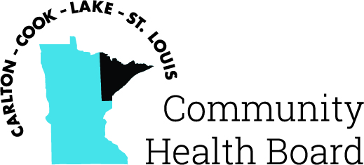

404 West Superior Street, Suite 250
Duluth, MN 55802
Phone: 218-733-2860
www.communityhealthboard.org

Notice of a Public Meeting

February 7, 2024

Notice is hereby given that a meeting of the Board of Directors
of the Carlton-Cook-Lake-St. Louis Community Health Board will be
held on Monday, February 12, at 12:30 p.m. at the Richard H. Hansen Public Works and Transportation Complex located at 4787 Midway Road, Pike Lake, MN for the purpose of conducting regular business.

All voting members will be present except for Annie Harala who will be attending the meeting virtually from the following address: 1919 Connecticut Ave. NW, Washington, DC 20009, and Rick Hogenson who will be attending virtually from the following address: 601 3rd Ave., Two Harbors, MN 55616.

For additional details please contact CHBSupport@CommunityHealthBoard.org.

